- ONLINE SUPPLEMENTAL DATA –

THE MD-PhD PROGRAM IN GENEVA: A 10-YEAR ANALYSIS OF DEMOGRAPHICS AND OUTCOMES

Andre Dos Santos Rocha^{1,2}, Cristophe Combescure³, Francesco Negro^{4,5}

¹ Unit for Anaesthesiological Investigations, Department of Acute Medicine, University of Geneva, Switzerland
² European MD-PhD Association, Groningen, The Netherlands
³ Division of Clinical Epidemiology, University Hospitals of Geneva, Switzerland
⁴ MD-PhD Committee, Faculty of Medicine, University of Geneva, Switzerland
⁵ Divisions of Gastroenterology and Hepatology and of Clinical Pathology, University Hospitals of Geneva, Geneva, Switzerland.

ADDRESS FOR CORRESPONDENCE:

Andre Dos Santos Rocha, MD
Unit for Anaesthesiological Investigations
Rue Michel-Servet 1, 1206 Genève, Switzerland
Phone: +41 (0)79 553 21 36
Email: Andre.DosSantosRocha@unige.ch

TABLE S1 - Questionnaire for MD-PhD graduates from Université de Genève
- Please specify your age:
- Gender: Male / Female
- What is your current country of work or training?
- What is your marital status?
  - Single
  - Single Parent
  - Married/With Partner
  - Married/With Partner Parent
  - Do not want to answer
- When did you obtained your MD-PhD degree?
- How long did your MD-PhD training last?
  - 3 years
  - 3 ½ years
  - 4 years
  - 4 ½ years
  - 5 years
  - Other:
- In which field did you perform your MD-PhD research?
  - Basic science
  - Translational research
  - Clinical research
- How was your MD-PhD training funded?
  - Grant from Swiss National Science Foundation (SNSF)
  - Grant from Host lab/institution
  - Grant from private Institute / Foundation
  - Other:
- Have you completed a specialty training (FMH specialist) - Yes / No?
- What position(s) do you currently have? (please select several options)
  - University hospital – resident (Interne)
  - University hospital - Senior Registrar (Chef de clinique)
  - University hospital – Consultant (Médecin adjoint et plus)
  - Professor at Swiss University
  - Professor at foreign University
  - Peripheral hospital practitioner
  - Private practice practitioner
  - Researcher (either clinical or laboratory)
  - FMH specialist
  - University teaching (without professorship)
  - Industry
  - Public health policy
  - Non-medical (consultancy/business, journalism, politics etc.)
- How many original papers did you publish during your MD-PhD studies?
- How many original papers did you publish since you obtained the MD-PhD degree?
- Do you consider that your MD-PhD degree gave you an edge during your career?
  - Yes, it granted me access to better clinical positions
  - Yes, it granted me access to better research positions
  - Yes, it granted me access to better academic positions
  - Yes, it granted me access to post-doc funding
  - No, it gave me no advantage
- How much of your working time is currently devoted to research?
  - 0%
  - 0-20%
  - 20-40%
  - 40-60%
  - 60-80%
  - 100%
- What is the nature of the research you are doing?
  - Clinical
  - Basic Science
  - Translational
  - Public Health/Policy Making
  - Other:
  - N/A
- What have been the three most pressing obstacles/challenges to combine clinical work and research?
  - None
  - Lack of (protected) time
  - Lack of mentoring
  - Under-compensation
  - Lack of funding
  - Lack of opportunity
  - Not finding position in desired location
  - Balancing family and work responsibilities
  - Satisfactory professional advancement
  - Discrimination against your gender/ethnicity/sexual orientation
  - Other:
- How satisfied are you with the MD-PhD programme in Université de Genève? (scale 1-10)
- How strongly would you suggest the MD-PhD programme in Université de Genève to a colleague/student that is interested in research? (scale 1-10)
- Would you do it again? - Yes / No?
- Are there any other comments that you would like to give?

TABLE S2: MD-PhD program characteristics and outcomes, considering the different fields of MD-PhD research

 | Field of MD-PhD research
 | Basic science | Clinical research | Translational research
n | 12 | 4 | 5 | p=0.0304 (Kruskal-Wallis test)
Number of publications during MD-PhD |  |  |  | p=0.0304 (Kruskal-Wallis test)
Median (min-max) | 4.0 (2.0 to 20.0) | 7.5 (5.0 to 11.0) | 2.0 (0.0 to 7.0) | p=0.0304 (Kruskal-Wallis test)
MD-PhD duration, n (%) |  |  |  | p=0.66 (Fisher exact test)
3 years | 5 (41.7%) | 2 (50.0%) | 2 (40.0%) | p=0.66 (Fisher exact test)
4 years (including 3.5 y) | 4 (33.3%) | 2 (50.0%) | 1 (20.0%) | p=0.66 (Fisher exact test)
5 years | 3 (25.0%) | 0 (0.0%) | 2 (40.0%) | p=0.66 (Fisher exact test)
Gender, n (%) |  |  |  | p=0.57 (Fisher exact test)
Female | 3 (25.0%) | 2 (50.0%) | 2 (40.0%) | p=0.57 (Fisher exact test)
Male | 9 (75.0%) | 2 (50.0%) | 3 (60.0%) | p=0.57 (Fisher exact test)
Age at time of MD-PhD graduation, years |  |  |  | p=0.14 (Kruskal-Wallis test)
Median (min-max) | 31 (27 to 35) | 35 (31 to 46) | 30 (27 to 36) | p=0.14 (Kruskal-Wallis test)
MD-PhD funding, n (%) |  |  |  | p=0.53 (Fisher exact test)
European grant | 1 (8.3%) | 0 (0.0%) | 0 (0.0%) | p=0.53 (Fisher exact test)
Grant from host lab / institution | 7 (58.3%) | 3 (75.0%) | 3 (60.0%) | p=0.53 (Fisher exact test)
Grant from SNSF* | 4 (33.3%) | 0 (0.0%) | 2 (40.0%) | p=0.53 (Fisher exact test)
Grant from SCES** | 1 (25.0%) | 0 (0.0%) | 2 (40.0%) | p=0.53 (Fisher exact test)
Current field of research
Basic science | 3 (25.0%) | 0 (0.0%) | 0 (0.0%)
Clinical research | 2 (16.7%) | 4 (100.0%) | 0 (0.0%)
Translational research | 4 (33.3%) | 0 (0.0%) | 2 (20.0%)
No reasearch activity | 3 (25.0%) | 0 (0.0%) | 3 (60.0%)
Current position, n (%)
Peripheral hospital practitioner | 1 (8.3%) | 0 (0%) | 0 (0%)
Private health care practitioner | 1 (8.3%) | 0 (0%) | 0 (0%)
Research (either clinical or laboratory) | 1 (8.3%) | 2 (50%) | 0 (0%)
University hospital - resident (interne) | 3 (25%) | 0 (0%) | 3 (60%)
University hospital - senior registrar (chef de clinique) | 3 (25%) | 1 (25%) | 1 (20%)
University hospital - subspeciality fellow | 1 (8.3%) | 0 (0%) | 0 (0%)
University hospital - consultant (médecin adjoint et plus) | 2 (16.7%) | 1 (25%) | 1 (20%)
Time dedicated to research in current position, n (%)
0% | 3 (25.0%) | 0 (0.0%) | 3 (60.0%)
1-20% | 4 (33.3%) | 1 (25.0%) | 1 (20.0%)
21-40% | 1 (8.3%) | 0 (0.0%) | 0 (0.0%)
41-60% | 1 (8.3%) | 1 (25.0%) | 1 (20.0%)
61-80% | 1 (8.3%) | 1 (25.0%) | 0 (0.0%)
81-99% | 1 (8.3%) | 0 (0.0%) | 0 (0.0%)
100% | 1 (8.3%) | 1 (25.0%) | 0 (0.0%)
Field of research research in persons with at least 1% of time dedicated
to research
Basic science | 3 (33.3%) | 0 (0.0%) | 0 (0.0%)
Clinical research | 2 (22.2%) | 4 (100.0%) | 0 (0.0%)
Translational research | 4 (44.4%) | 0 (0.0%) | 2 (100.0%)

*SNSF: Swiss National Science Foundation **SCES: Swiss Confederation Excellence Scholarship

TABLE S3: Characteristics and outcomes of MD-PhD graduates, considering gender.

 | Female (n=7) | Male (n=14)
Field MD-PhD
Basic science | 3 (42.9%) | 9 (64.3%)
Clinical research | 2 (28.6%) | 2 (14.3%)
Translational research | 2 (28.6%) | 3 (21.4%)
MD-PhD duration, n (%) |  |  | p=0.64 (Fisher exact test)
3 years | 2 (28.6%) | 7 (50%) | p=0.64 (Fisher exact test)
4 years (including 3.5 y) | 2 (28.6%) | 5 (35.7%) | p=0.64 (Fisher exact test)
5 years | 3 (42.9%) | 2 (14.3%) | p=0.64 (Fisher exact test)
Number of publications during MD-PhD |  |  | p=0.82 (Mann-Whitney test)
Median (min-max) | 4.0 (1.0 to 11.0) | 4.0 (0.0 to 20.0) | p=0.82 (Mann-Whitney test)
Current position
Peripheral hospital practitioner | 0 (0.0%) | 1 (7.1%)
Private health care practitioner | 0 (0.0%) | 1 (7.1%)
Research (either clinical or laboratory) | 2 (28.6%) | 1 (7.1%)
University hospital - resident (interne) | 2 (28.6%) | 4 (28.6%)
University hospital - senior registrar (chef de clinique) | 1 (14.3%) | 4 (28.6%)
University hospital - subspeciality fellow | 1 (14.3%) | 0 (0.0%)
University hospital - consultant (médecin adjoint et plus) | 1 (14.3%) | 3 (21.4%)
Time dedicated to research in the current position, n (%)
0% | 2 (28.6%) | 4 (28.6%)
1-20% | 1 (14.3%) | 5 (35.7%)
21-40% | 0 (0%) | 1 (7.1%)
41-60% | 1 (14.3%) | 2 (14.3%)
61-80% | 1 (14.3%) | 1 (7.1%)
81-99% | 1 (14.3%) | 0 (0%)
100% | 1 (14.3%) | 1 (7.1%)
Number of publications per year after MD-PhD |  |  | p=0.0221 (Mann-Whitney test)
Median (min-max) | 0.3 (0.0 to 2.0) | 1.9 (0.4 to 4.2) | p=0.0221 (Mann-Whitney test)
Number of publications per year after MD-PhD in persons with at least 1% of time dedicated to research (n=15) |  |  | p=0.0316 (Mann-Whitney test)
n | 5 | 10 | p=0.0316 (Mann-Whitney test)
Median (min-max) | 1.0 (0.0 to 2.0) | 2.1 (0.7 to 4.2) | p=0.0316 (Mann-Whitney test)
Do you consider that your MD-PhD degree gave you an edge during your career?
No | 1 (14.3%) | 2 (14.3%)
Yes | 6 (85.7%) | 12 (85.7%)
If Yes (n=18),
n | 6 | 12
Better clinical position | 4 (66.7%) | 10 (83.3%)
Better academic or research position | 5 (83.3%) | 8 (66.7%)
Better post-doc funding | 2 (33.3%) | 2 (16.7%)
Are there any pressing obstacles/challenges to combine clinical work and research?
No | 1 (14.3%) | 2 (14.3%)
Yes | 6 (85.7%) | 12 (85.7%)
If Yes, what have been the most pressing obstacles/challenges?
n | 6 | 12
Lack of time | 4 (66.7%) | 7 (58.3%)
Lack of mentoring | 2 (33.3%) | 4 (33.3%)
Under compensation | 0 (0.0%) | 5 (41.7%)
Lack of funding | 2 (33.3%) | 4 (33.3%)
Balance with family | 3 (50.0%) | 4 (33.3%)
Other | 3 (50.0%) | 4 (33.3%)
How satisfied are you with the MD-PhD programme ? (0-10 scale)
Median (min-max) | 8.0 (7.0 to 10.0) | 8.5 (4.0 to 10.0)
How strongly would you suggest the MD-PhD programme to a colleague/student that is interested in research? (0-10 scale)
Median (min-max) | 8.0 (8.0 to 10.0) | 9.0 (1.0 to 10.0)

FIGURE S1 – Number of publications during MD-PhD training (left), represented by gender. On the right, number of publications per year since MD-PhD graduation, represented by gender.

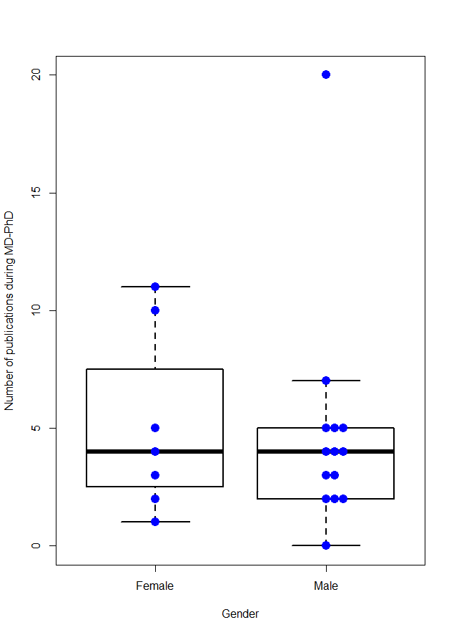
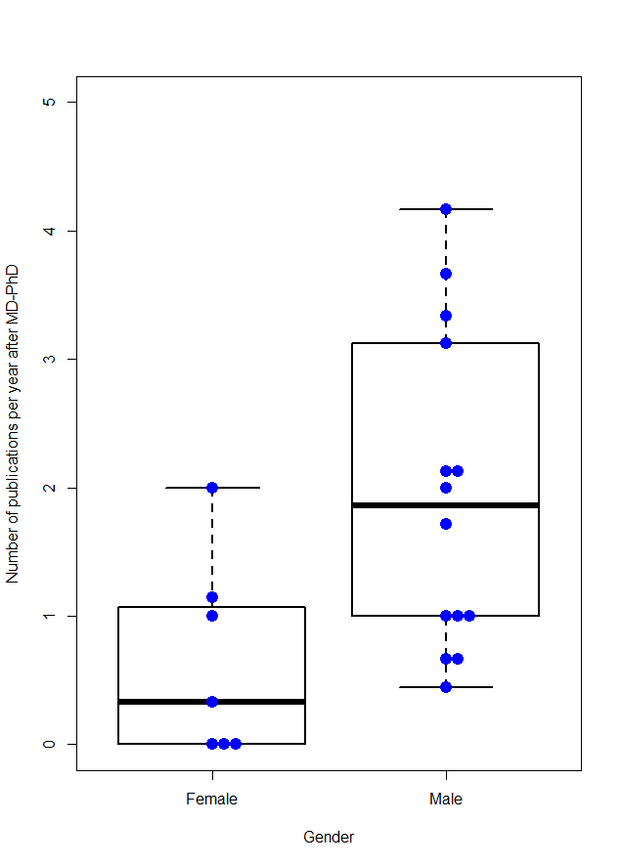
p = 0.022 (Mann-Whitney test)

